**DA Assignment 3**

**Name: Ragala Santhi**

**20KH1A0477**

**2020ece.r77@svck.edu.in**

* Define at least two sets based on specific criteria from your dataset (e.g., high-value customers, top-performing products).

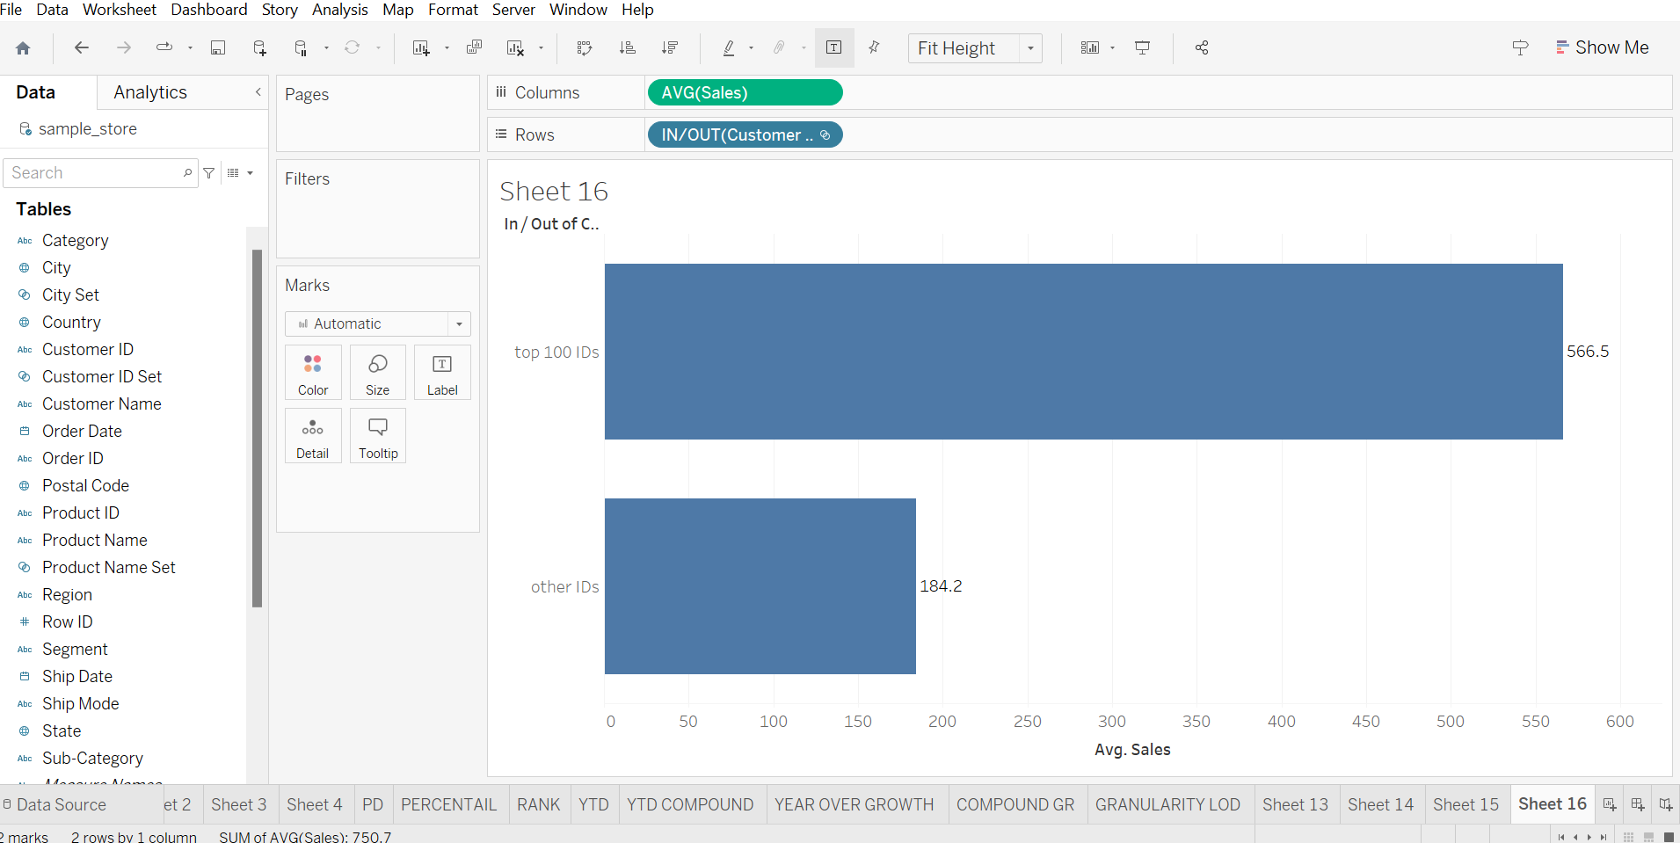

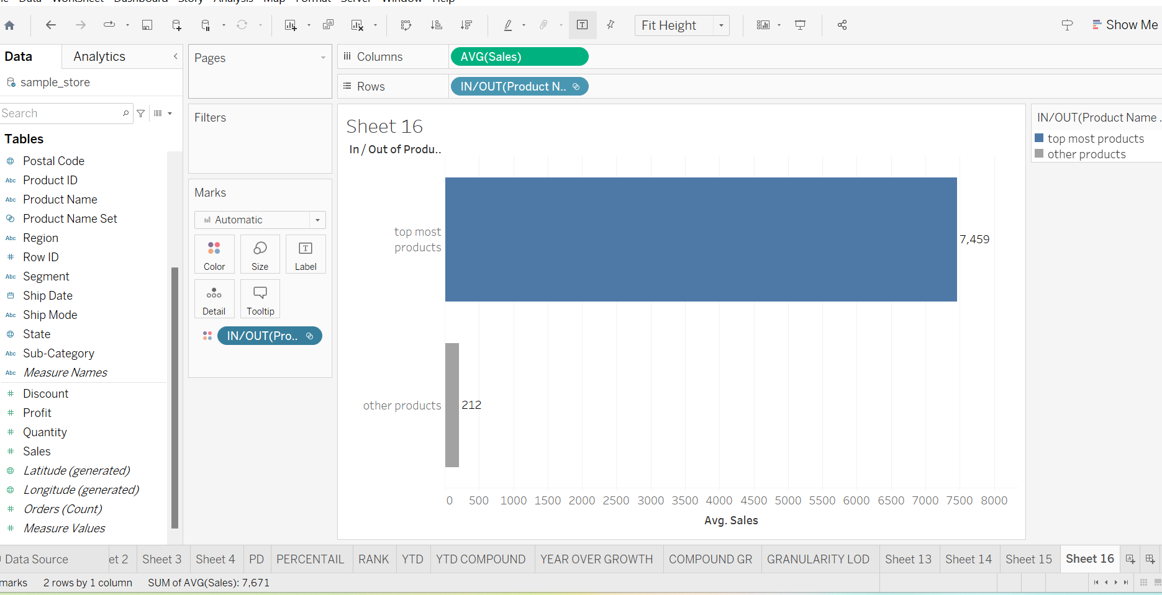

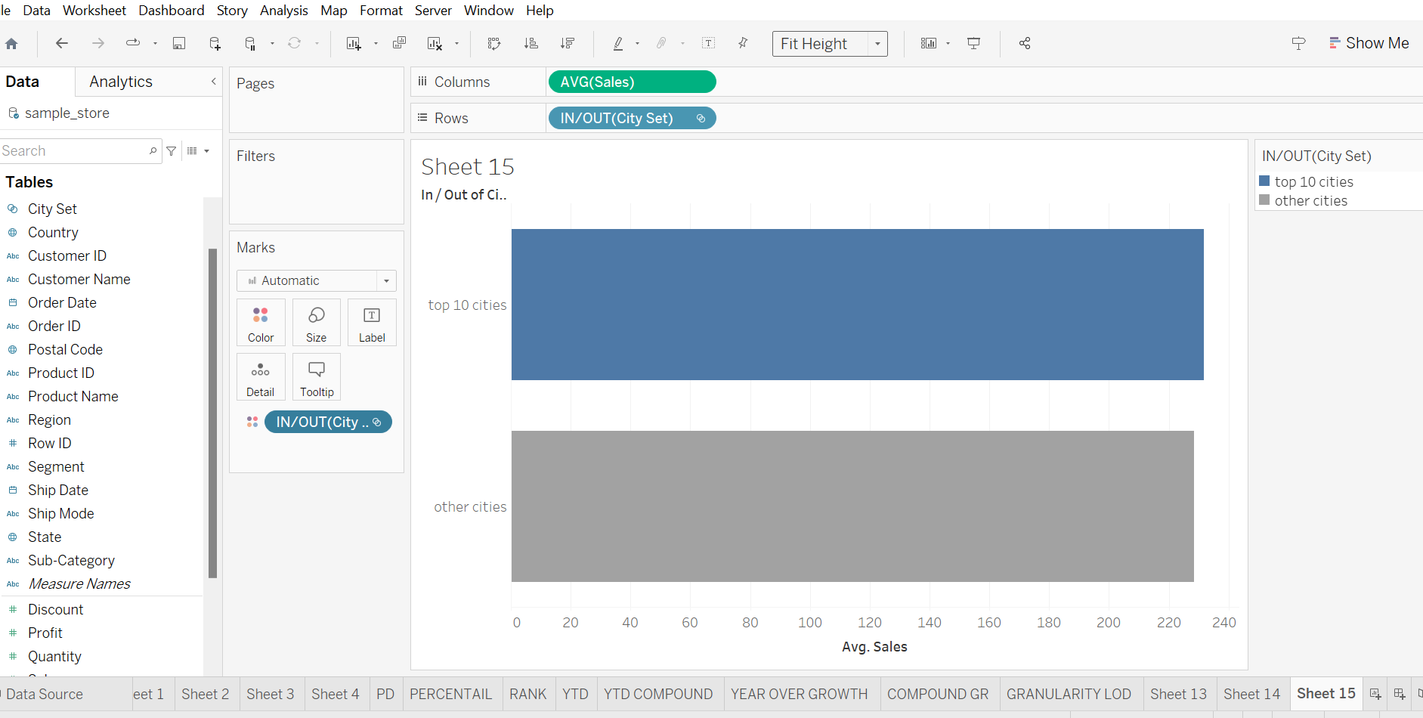

* Experiment with combining sets using UNION, INTERSECT, and MINUS operations.

**MINUS, INSERT, UNION**

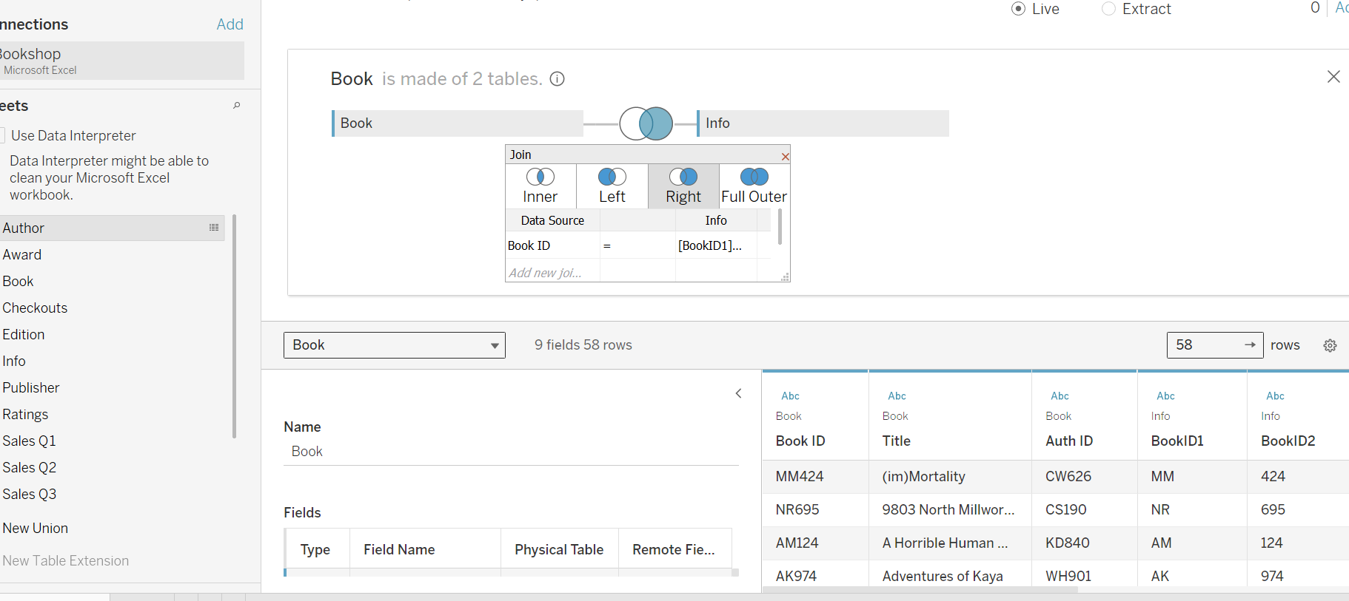

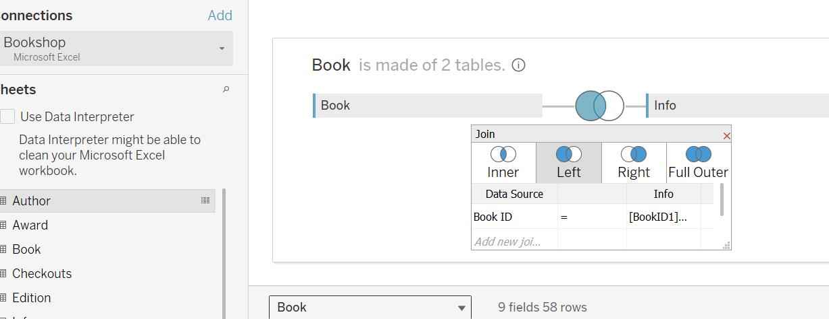

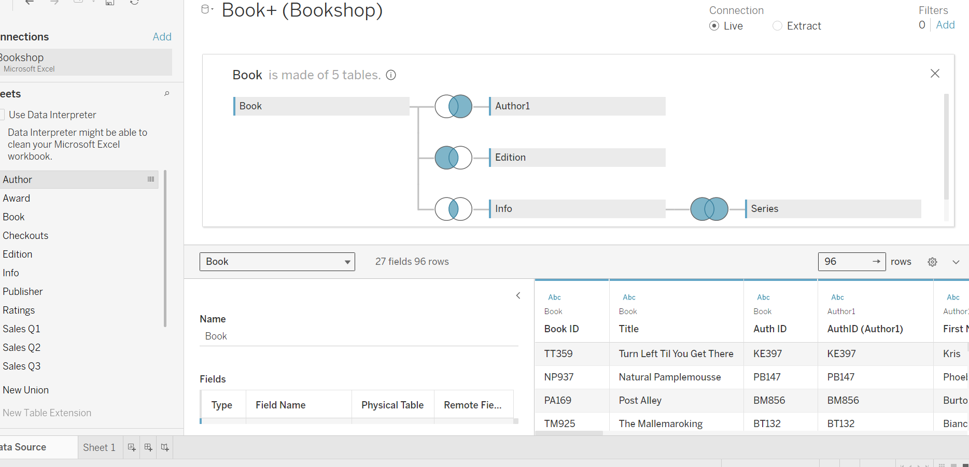

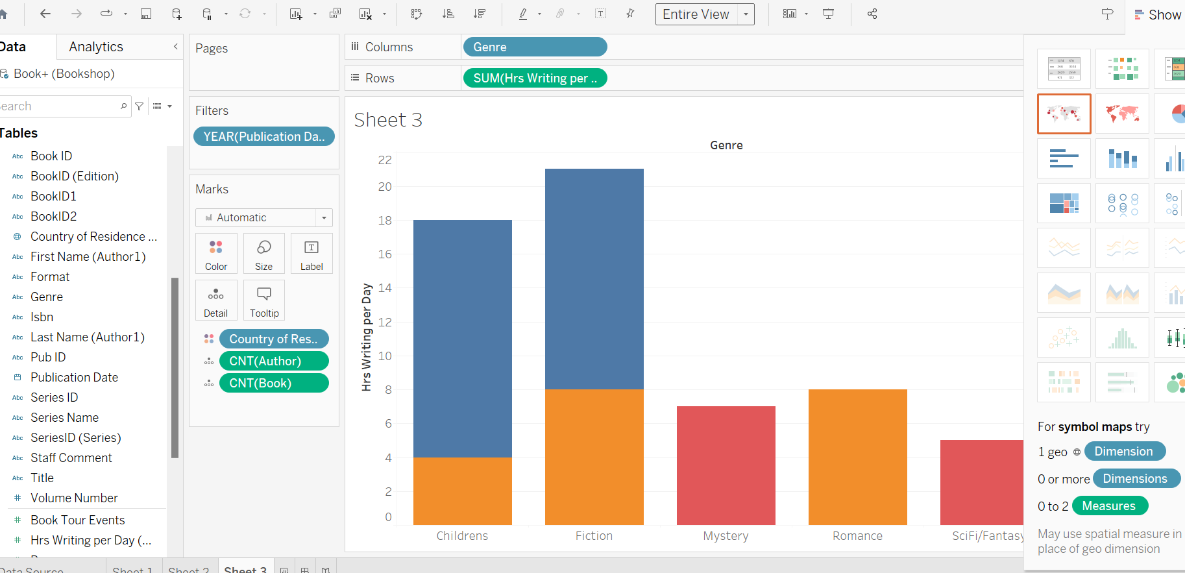

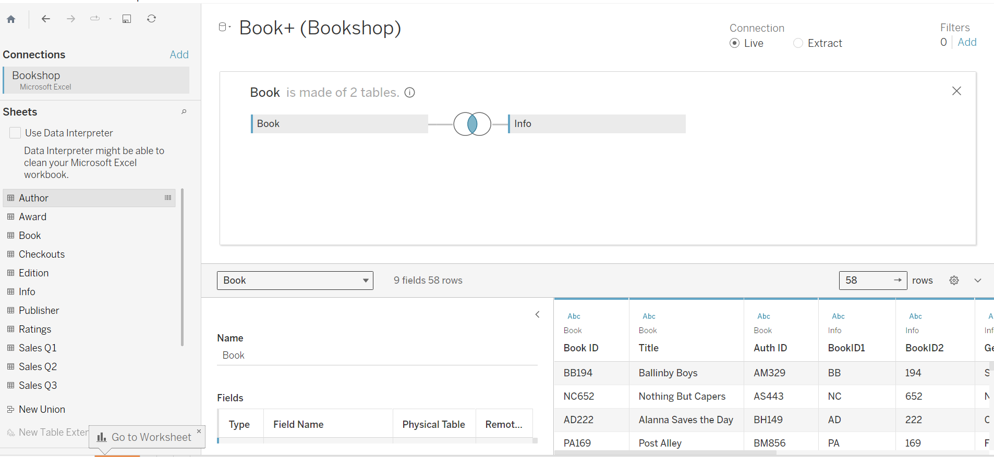

* Create 2 Calculation field using any aggregate function

[PROFIT]-[DISCOUNT]:

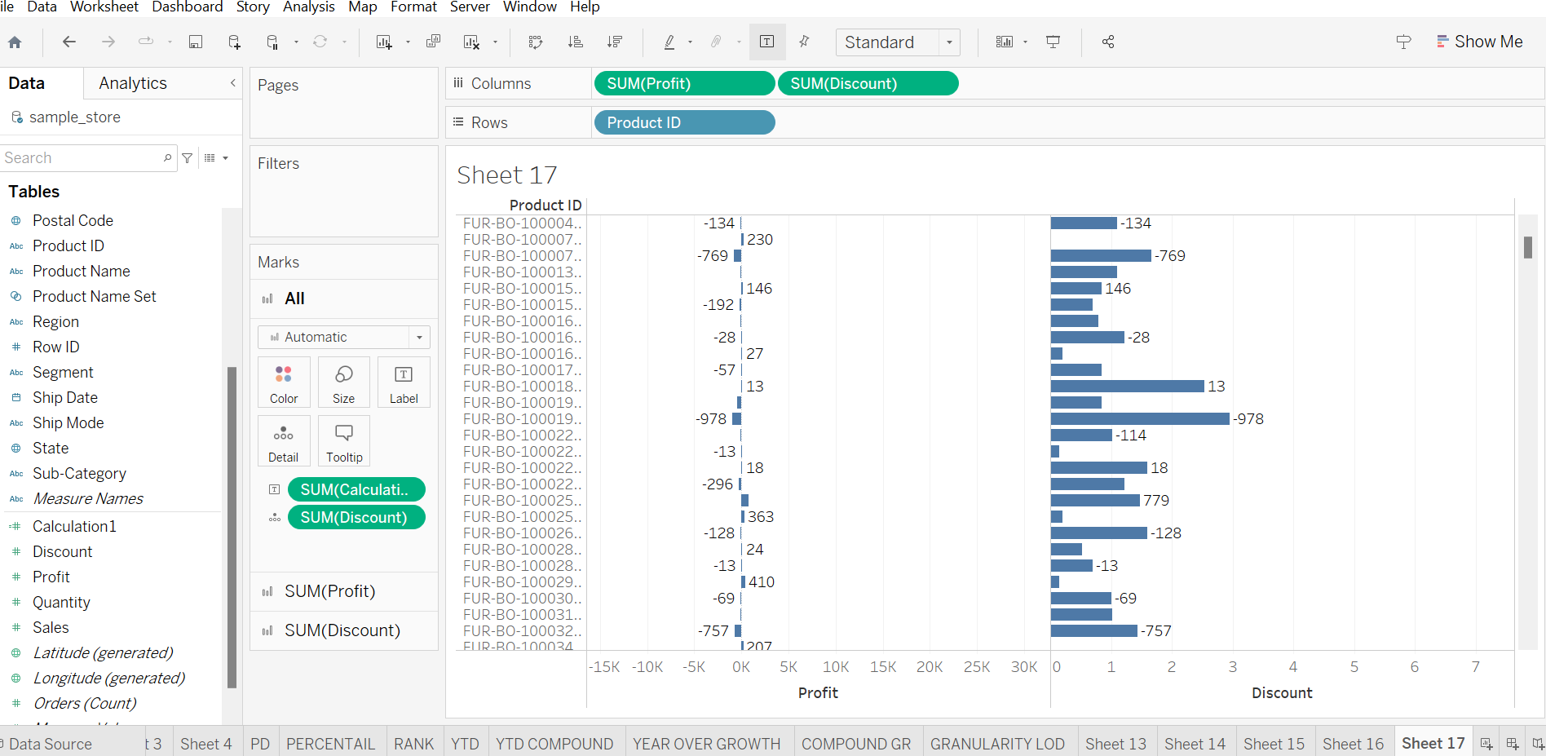

IF[PROFIT] > 0 THEN ”PROFITABLE”

ELSE “NON PROFITABLE” END

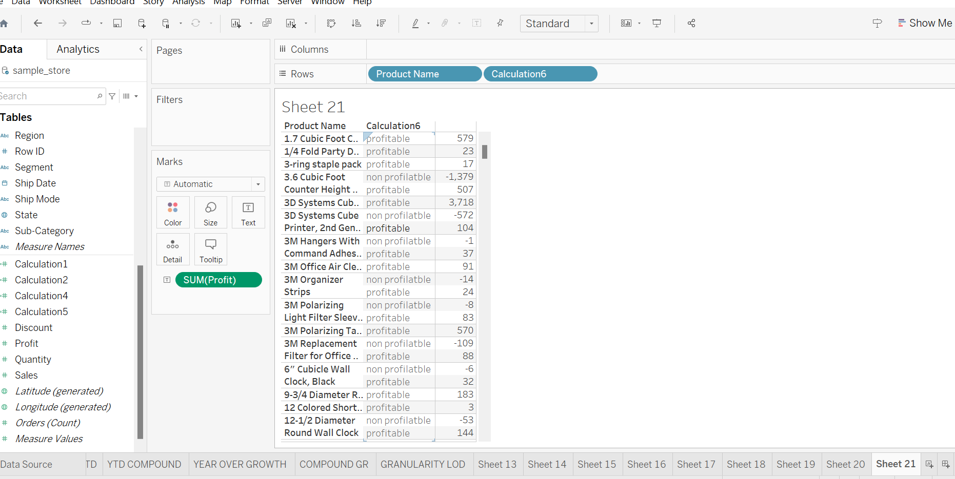

([PROFIT] - [DISCOUNT]) / ABS([DISCOUNT])

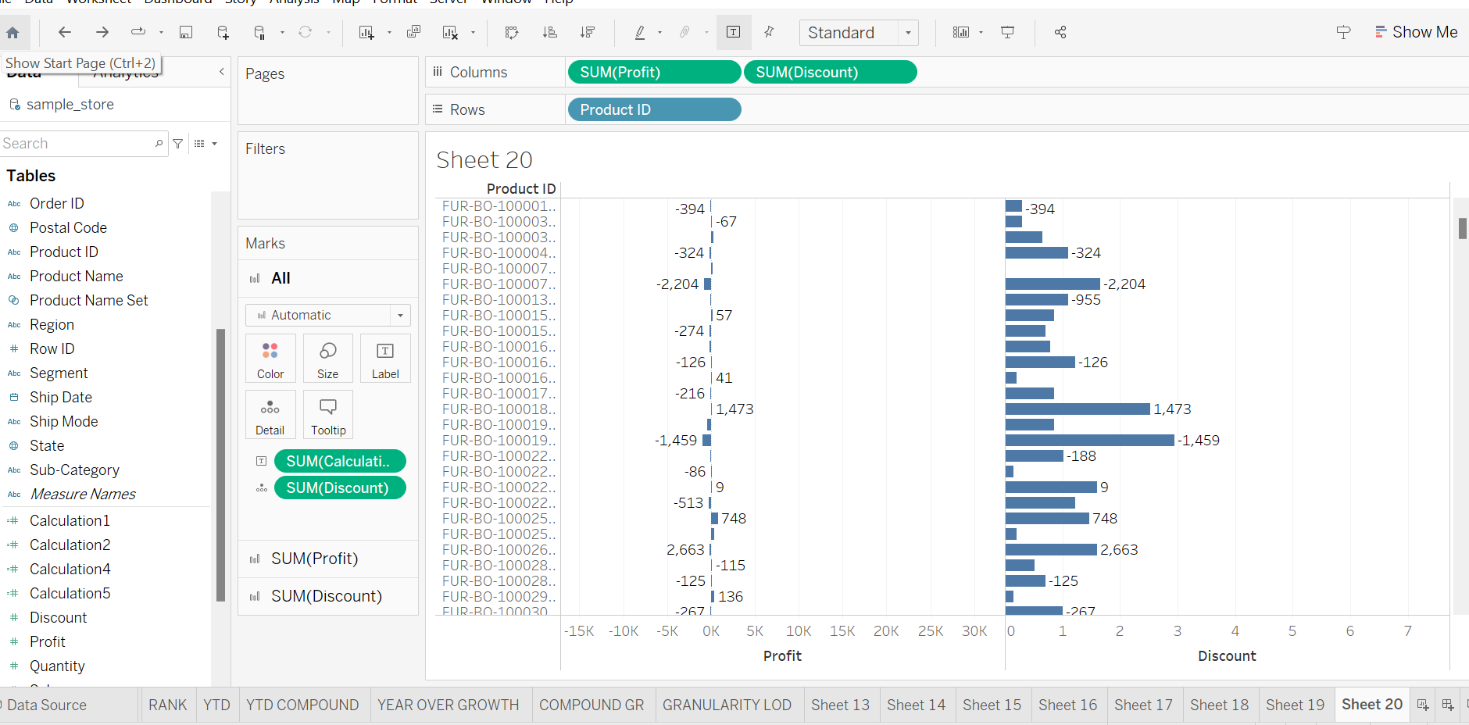

* 3 visualization using quick Table Calculations Dataset

COMPOUND GROWTH RATE:

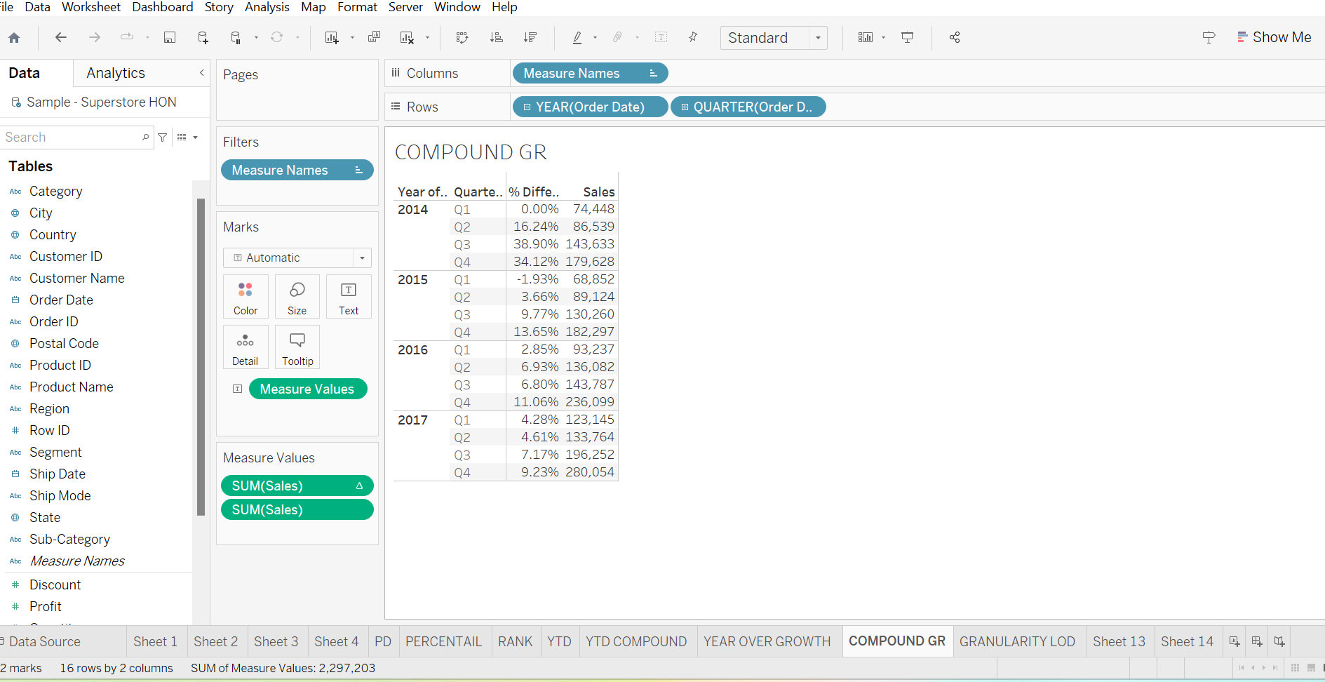

PERCENTAIL

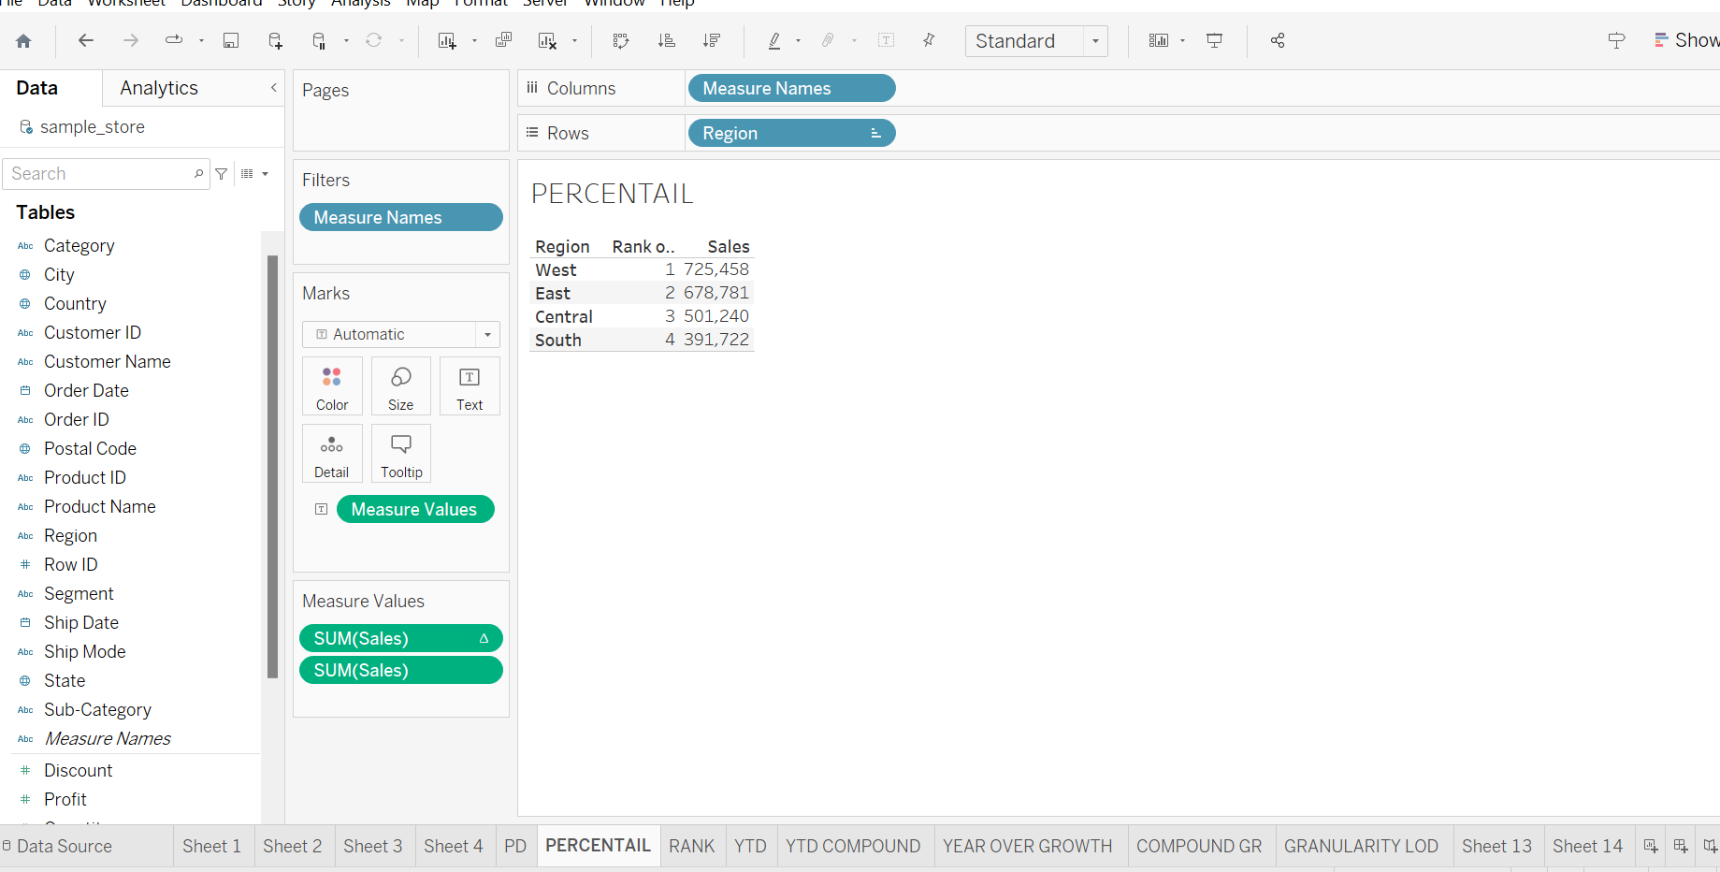

YEAR TO DATE:

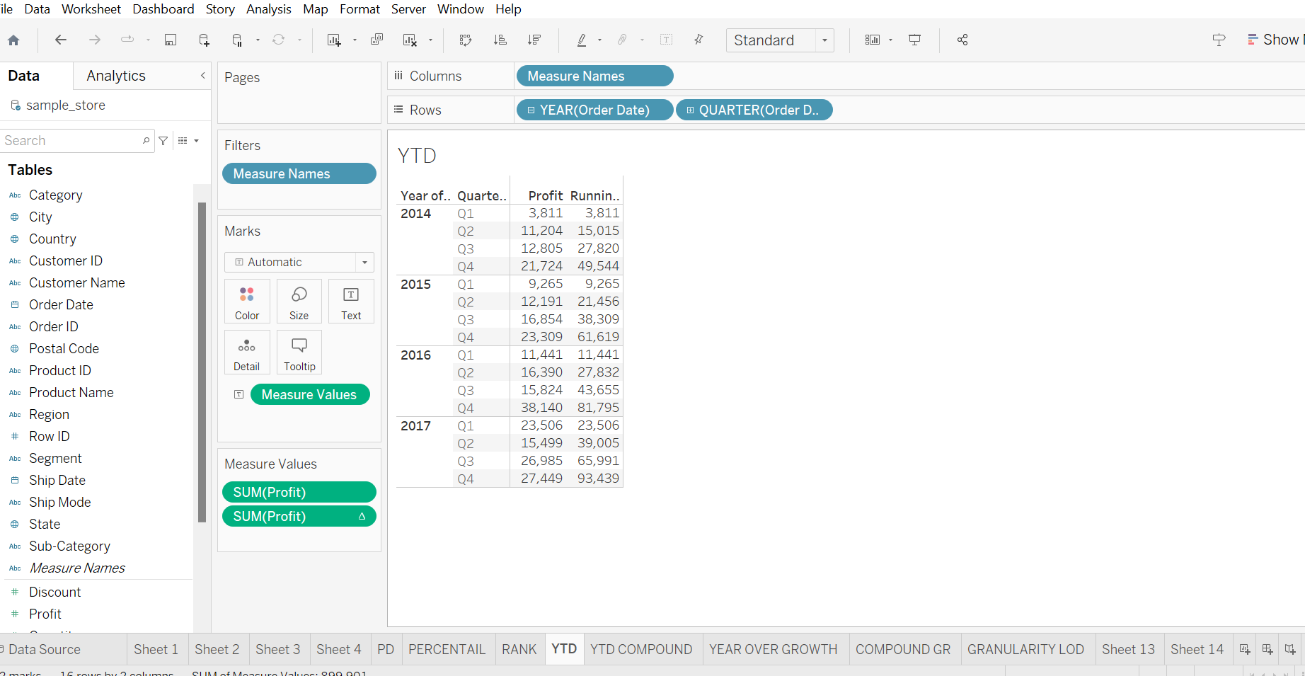

YEAR TO DATE COMPOUND:

